1. **Problem 21.5** 
   1. **Integrate the following function both analytically and using Simpson’s rules, with n = 4 and 5. Discuss the results.**

First let’s plot the function with the limits and calculate the integration analytically.

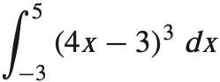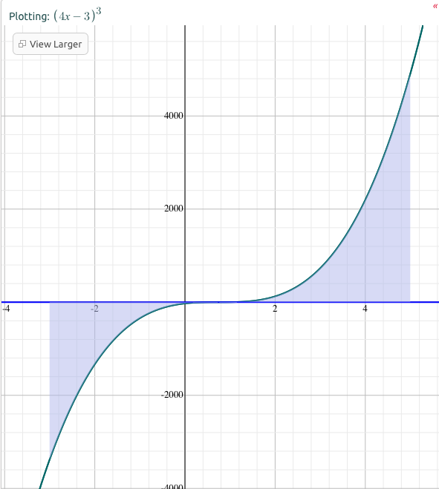

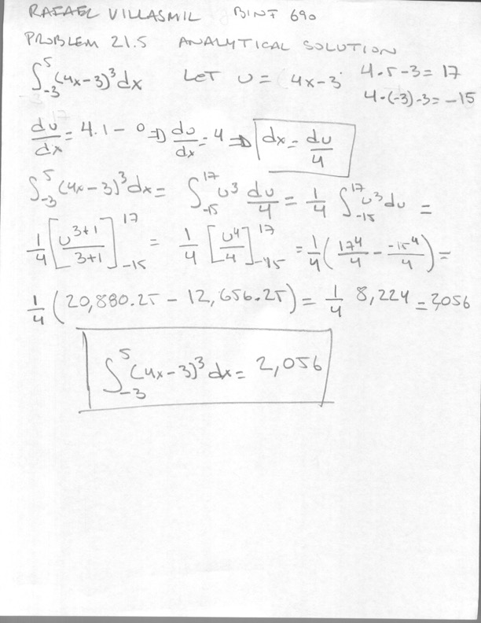

Here is the estimate of the integration by the Simpson’s rule. I see no difference in the n=4 or 5 application in the total error (Etotal) or estimated of the percent relative error (Ea). The calculations are in the excel file in the Simpsons Workspace.

|  |  |  |  |  |  |  |
| --- | --- | --- | --- | --- | --- | --- |
| N | 4 | |  | N | 5 | |
| a | -3 | |  | a | -3 | |
| b | 5 | |  | b | 5 | |
|  |  | |  |  |  | |
|  |  | |  |  |  | |
| h | 2 | |  | h | 1.6 | |
|  |  | |  |  |  | |
| X | F(x) = (4x-3)^3 | |  | X | F(x) = (4x-3)^3 | |
| -3 | -3375 | |  | -3 | -3375 | |
| -1 | -343 | |  | -1.4 | -636.056 | |
| 1 | 1 | |  | 0.2 | -10.648 | |
| 3 | 729 | |  | 1.8 | 74.088 | |
| 5 | 4913 | |  | 3.4 | 1191.016 | |
|  |  | |  | 5 | 4913 | |
|  |  | |  |  |  | |
| I | 2056 | |  | I1-3 | -3162.5984 | |
| Analytical Calculation | 2056 | |  | I3-5 | 5218.5984 | |
| Etotal | 0 | |  | I | 2056 | |
| Ea | 0% | |  | Analytical Calculation | 2056 | |
|  |  | |  | Etotal | 0 | |
|  |  |  | | Ea | | 0% |

* 1. In addition,
     1. (a) compute integral using trapezoidal rule (n=5);

The estimate of the Integration using the trapezoidal rule with five segments has an estimated of the percent relative error (Ea) of 8%. The calculations are in the excel file in the Trapezoidal Rule Workspace.

|  |  |  |  |
| --- | --- | --- | --- |
| N | 5 |  |  |
| a | -3 |  |  |
| b | 5 |  |  |
| h | 1.6 |  |  |
|  |  |  |  |
| X | F(x) = (4x-3)^3 | Multiplier | Product for the sum |
| -3 | -3375 | 1 | -3375 |
| -1.4 | -636.056 | 2 | -1272.112 |
| 0.2 | -10.648 | 2 | -21.296 |
| 1.8 | 74.088 | 2 | 148.176 |
| 3.4 | 1191.016 | 2 | 2382.032 |
| 5 | 4913 | 1 | 4913 |
|  |  |  | 2774.8 |
| I | 2219.84 |  |  |
| Analytical Calculation | 2056 |  |  |
| Etotal | -163.84 |  |  |
| Ea | 8% |  |  |

* + 1. (b) compute integral using Romberg integration (n1=5, n2=10);

The table below shows the estimates of the Integration using Romberg integration with multiple segments and up to 10 iterations. The calculations are in the excel file in the Romberg integration Workspace.

|  |  |  |  |  |  |  |  |  |  |  |
| --- | --- | --- | --- | --- | --- | --- | --- | --- | --- | --- |
| Integration | 1 | 2 | 3 | 4 | 5 | 6 | 7 | 8 | 9 | 10 |
| n=1 | 6152.000000 |  |  |  |  |  |  |  |  |  |
| n=2 | 3080.000000 | 2056.000000 |  |  |  |  |  |  |  |  |
| n=4 | 2312.000000 | 2056.000000 | 2056 |  |  |  |  |  |  |  |
| n=8 | 2120.000000 | 2056.000000 | 2056 | 2056 |  |  |  |  |  |  |
| n=16 | 2072.000000 | 2056.000000 | 2056 | 2056 | 2056 |  |  |  |  |  |
| n=32 | 2060.000000 | 2056.000000 | 2056 | 2056 | 2056 | 2056 |  |  |  |  |
| n=64 | 2057.000000 | 2056.000000 | 2056 | 2056 | 2056 | 2056 | 2056 |  |  |  |
| n=128 | 2056.250000 | 2056.000000 | 2056 | 2056 | 2056 | 2056 | 2056 | 2056 |  |  |
| n=256 | 2056.062500 | 2056.000000 | 2056 | 2056 | 2056 | 2056 | 2056 | 2056 | 2056 |  |
| n=512 | 2056.015625 | 2056.000000 | 2056 | 2056 | 2056 | 2056 | 2056 | 2056 | 2056 | 2056 |

Here is a table of the estimated of the percent relative error (Ea) for each iteration. The Romberg iteration minimized the error with one iteration of the estimated with two trapezoid segments. A two trapezoid Romberg integration is much more computational economical and has lower error than doing a 512-trapezoid estimate or equivalent to a 4-trapezoid with 1 integration.

|  |  |  |  |  |  |  |  |  |  |  |
| --- | --- | --- | --- | --- | --- | --- | --- | --- | --- | --- |
| Ea |  |  |  |  |  |  |  |  |  |  |
| n=1 | 199.222% |  |  |  |  |  |  |  |  |  |
| n=2 | 49.805% | 0.0% |  |  |  |  |  |  |  |  |
| n=4 | 12.451% | 0.0% | 0.0% |  |  |  |  |  |  |  |
| n=8 | 3.113% | 0.0% | 0.0% | 0.0% |  |  |  |  |  |  |
| n=16 | 0.778% | 0.0% | 0.0% | 0.0% | 0.0% |  |  |  |  |  |
| n=32 | 0.195% | 0.0% | 0.0% | 0.0% | 0.0% | 0.0% |  |  |  |  |
| n=64 | 0.049% | 0.0% | 0.0% | 0.0% | 0.0% | 0.0% | 0.0% |  |  |  |
| n=128 | 0.012% | 0.0% | 0.0% | 0.0% | 0.0% | 0.0% | 0.0% | 0.0% |  |  |
| n=256 | 0.003% | 0.0% | 0.0% | 0.0% | 0.0% | 0.0% | 0.0% | 0.0% | 0.0% |  |
| n=512 | 0.001% | 0.0% | 0.0% | 0.0% | 0.0% | 0.0% | 0.0% | 0.0% | 0.0% | 0.0% |

* + 1. (c) compare numerical results with analytical integration.

Again, the Simpson estimations were very effective for the function provided. Trapezoid integration with 16-segments approximated the analytical solution with an error bellow 1%. There is a great computational cost in increasing the number of segments for the trapezoidal integration. The Romberg iteration produced a result identical to the analytical solution with minimal iterations.

1. Compute the integral for the 3rd order interpolating polynomial from the derivation of 1/3 Simpson method done in the class.

